* Tomcat server is web server software upto 6.0v . It is Application server from 7.0v because more feature were added to it.
* Tomcat server is light weight server, takes less space in memory, easty to start, easty to stop . Usually, tomcat server is used in Development and testing environment because During those environments, we give few requests to server for web application at a time.
* In production environment(After releasing and hosting), we don’t deploy web application in tomcat server. Because more no.of request will come for web application at a time.

Therefore we need special application server like **glashfilsh and wildfly**.

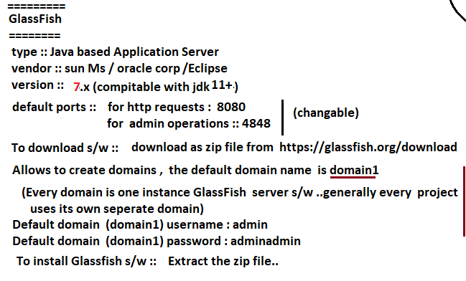

Note:-



Procedure to create custom Domain name in Glash-Fish server

======================== ====================

1. Open cmd.
2. Go to following directory.



3.

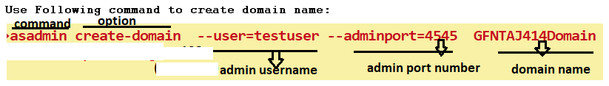

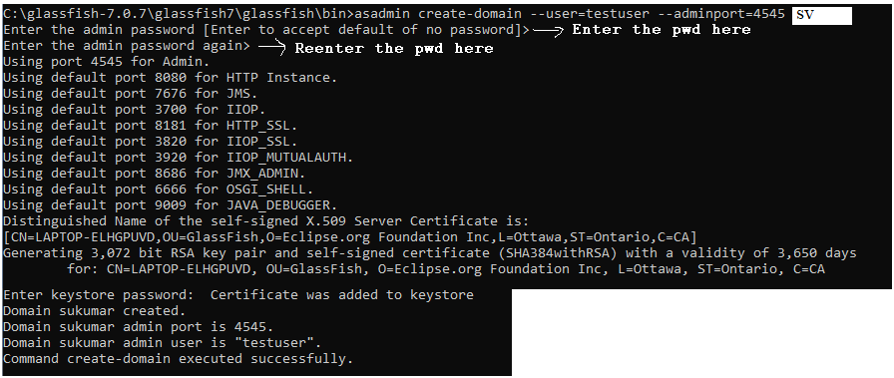

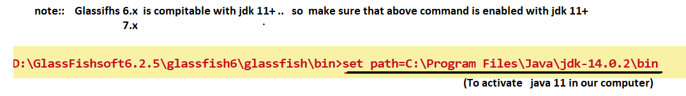

1. Change the http port number of glash fish server(After creating the domain):

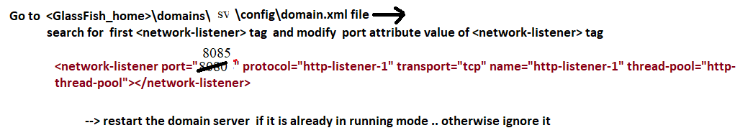

Procedure to deploy the web application using GlashFish server console:

======================================================

Step1: prepare the warfile presenting the web application.

Step2: start the GlashFish Application server.

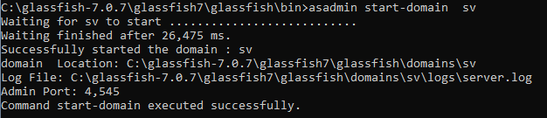

Step3: Open the admin console page of glash fish server.

<http://localhost:4545>

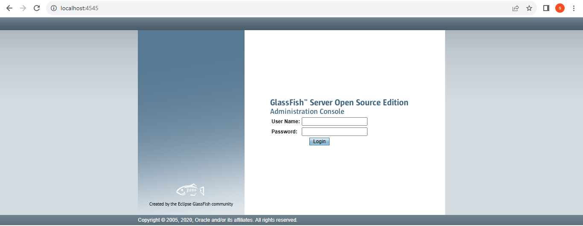

Enter the username:test-user

Enter the password:sv

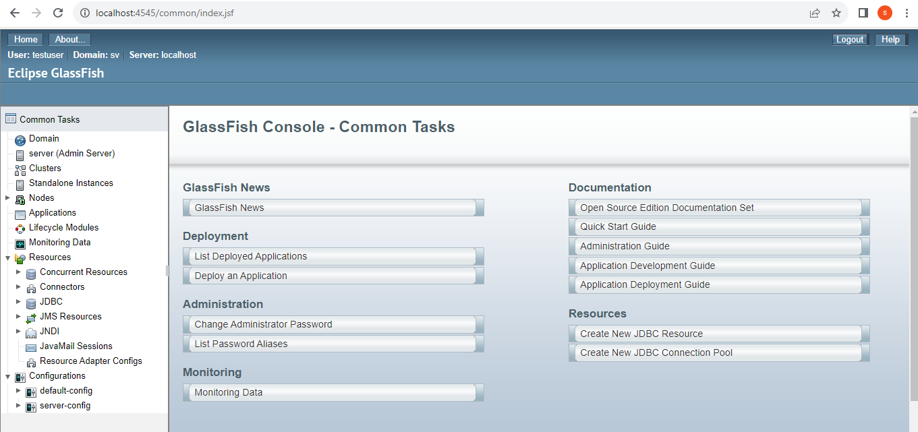

Step4: Deploy the web application



Step5: Test the Application.

5.1. Select the project checkbox.

5.2. click the enabled button.

5.3. press the launch button.

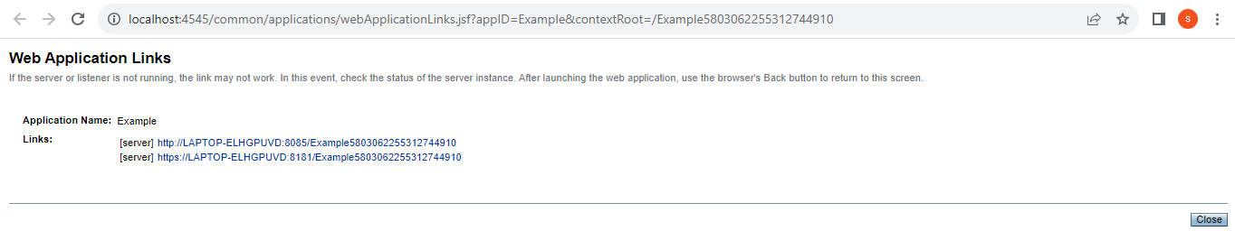

Step6: click on First hyper link. After pressing u will see the following index page of web application.

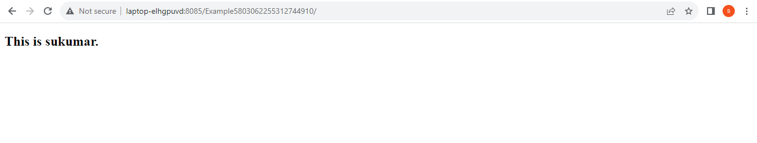

Process to UnDeploy the webapplication From GlashFish server using Console:

========================================================

